English and Maths

Y1 Miss Jewitt Week Beginning: 21st April 2020
Weekly Reading Task: | Try reading some of the poems from this website. They are all about the beautiful season of Spring  You can read them yourself or have them read to you.  https://www.nanascorner.com/22-spring-poems-for-children/
 | English Activity/ Objective | Maths Activity/Objective
Monday | Task 1: - It’s time to go for a lovely Spring walk today to look for signs of Spring. You could make a photo frame to take out with you so that you can photograph signs of Spring. Here is an example of what that could look like.  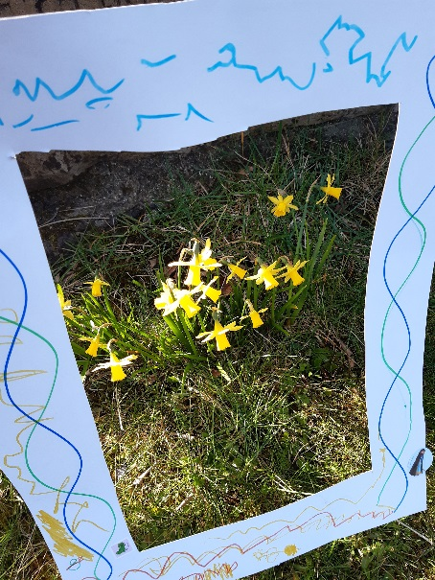  You can use cardboard or paper stuck onto cardboard and decorate it yourself.  As you walk around and spot the beautiful signs of Spring, I would like you to think of some amazing adjectives (describing words) to describe what you see. E.g – delightful daffodils. If you don’t have anything to make a photo frame don’t worry you can just take a photograph without one. | Task 1: Practise your number bonds to 20 by playing the game in the link below. Can you write your number bonds to 20? Could you write the numbers to 20 and number bonds snap with someone in your family? Take a photograph of your learning and send it by email to your teacher.  http://www.ictgames.com/saveTheWhale/index.html
Tuesday | Task 2: I hope that you enjoyed your walk yesterday! Today we are going to look at the pictures that you took of the signs of Spring. I would like you to write down all of those amazing adjectives that you thought of yesterday. Try to sound out the words to help you to spell them. | Task 2: Doubles. Practise your doubles by playing the funky mummy game below.  https://www.ictgames.com/mobilePage/funkyMummy/index.html  If you have playing cards at home you can put the cards in a stack, turn one over at a time and double the number.  You can also use a dice to practise doubles. Roll the dice and when it lands on a number, double it.
Wednesday | Task 3: Today we are going to learn about acrostic poems. What is an acrostic poem? Have a look at this website, it will show you.  https://www.youtube.com/watch?v=mfC-VjouV6c  Now write the word Spring down the page.  Splendid daffodils  Pretty flowers  R  I  N  G  Use your adjectives for each letter as above. If you feel ready for a challenge you could turn your words into sentences e.g. Pretty flowers dance in the wind. You can also decorate your poem when you are finished. | Task 3: Place Value  Can you play this game to help you to recognise two digit numbers and their value? Get your parents to keep track of your score to see how many points you get.  https://www.topmarks.co.uk/learning-to-count/place-value-basketball
Thursday | Task 4: We are spending all of our time at home at the moment so I thought that you might like do write your own acrostic poem about your family.  F  A  M  I  L  Y  You can think about all of the things that you love about your family and some adjectives to describe them. If you want to change the word family why not write an acrostic poem about your mam or sister or gran? Decorate it when you are finished. I’m sure when you share your work with them it will make their day! You can also share your favourite poem with your teacher by email. | Task 4; Recognising numbers 1-100  Choose a colour on this game. Play with an adult. Get the adult to choose a number and you have to splat that number on the number square. Adults can ask questions such as can you find the number 23? How many tens does it have? How many ones?  Can you tell me the number 1 more than 23 and colour it in? Can you find the number 10 more than 23 and colour it in? Can you find an odd/ even number?  https://www.topmarks.co.uk/learning-to-count/paint-the-squares
Friday | Task 5:  Use paper or coloured card if you have some, to draw around everyone who lives in your house’s hand. You can even do a paw print if you have a dog. Place the largest hand on the paper first then the next largest etc. Glue them onto the paper. This will be an amazing keepsake for your family to keep. If you don’t have any coloured card don’t worry you can use paper or recycled cardboard and colour the hands in instead. Next think of an adjective for each family member. Write it on the end finger of each hand.  This is an example of how your hands might look. This was my family’s handprints. You can share this with your teacher if you would like to.  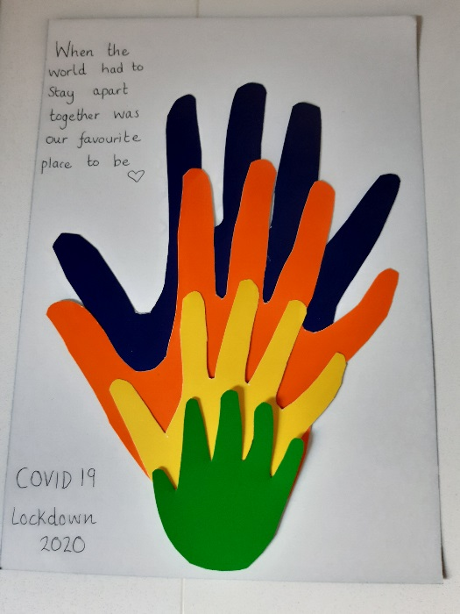 | Task 5: Ordering numbers with a Spring theme  Look at the eggs and order the numbers from smallest to largest.  https://www.topmarks.co.uk/Flash.aspx?f=SpringNumber

